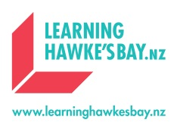**LEARNING HAWKE’S BAY 2020-21 SUMMER PROGRAMME**

Covid-19 has made it tough for everyone this year. We know many international students cannot return home this summer and will stay in New Zealand. In Hawke’s Bay, we have developed some interesting programmes for international students to have fun, make friends and learn something, during this unique holiday. We offer two options:

1. Non-boarding: Joining the programme every morning for the day programme and go home at the end of the day[1];

2. Boarding: Stay the whole week at [Lindisfarne College](https://www.lindisfarne.school.nz/), with accommodation, on-site supervisors and 3 meals provided, plus the daily activities. Students will arrive on the Monday morning and depart on Sunday morning after breakfast.

**Places are limited.** **Apply now to secure your place!**

**LHB Programme Week 1 - For students who just want to have fun**



***Price for Week 1: NZD630 per student non-boarding, or NZD1,140 if boarding.***

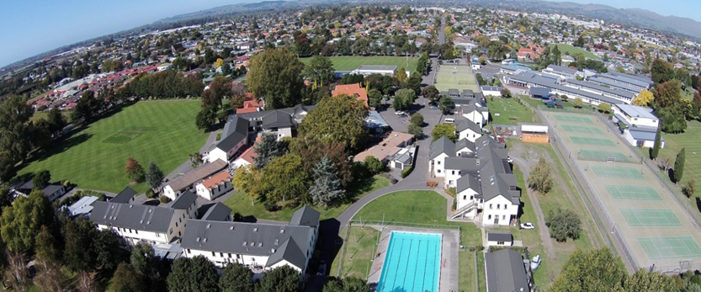

**LHB Programme Week 2 - For students who want to develop hobbies or learn something interesting**



***Price for Week 2: NZD660 per student non-boarding, or NZD1,180 if boarding.***

**LHB Programme Week 3 & 4 - For students who want to improve English**





***Price for Week 3: NZD630 per student non-boarding, or NZD1,140 if boarding.***

***Price for Week 4: Same as Week 3.***

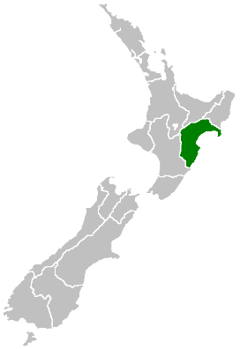**IMPORTANT**

* This programme will be available to all students in New Zealand attending in years 9-13, inclusive.
* Some part of the programmes may change, subject to availability, weather etc.
* Students can apply for one week, multiple weeks or consecutive weeks. Purchase of 2 weeks will pay $50 less, 3 weeks pay $100 less, and 4 weeks $150 less.
* Costs of horse trekking ($80 per person), white water rafting ($120 per person) and yachting (to be confirmed) are not included in the package.
* All participating international students must have insurance as required by the NZ Government.
* **Students must apply to LHB first, using the form below**. Enrolment is subject to availability and meeting the minimum number required. LHB will confirm enrolment and advise on payments etc following students’ applications.
* Full refund will be provided if, for reasons beyond our control, these programmes cannot be carried out, such as Covid-19 lockdown.
* LHB remains the right to remove students from this programme for behaviour issues, and no refund will be issued as a result of this removal.

**PLEASE DOWNLOAD THE APPLICATION FORM, FILL THIS OUT AND EMAIL IT TO:** [regional.manager@learninghawkesbay.nz](mailto:regional.manager@learninghawkesbay.nz) **BY 30 NOVEMBER 2020.**

BY SUBMITTING THE APPLICATION FORM AND MAKING A PAYMENT, YOU AGREE TO ALL TERMS AND CONDITIONS OF THIS SALE.

1. You can expect to pay around $300 per week for a homestay in Hawke’ Bay.